We define: 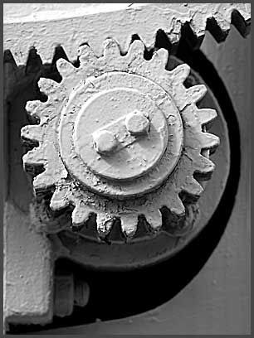

Geometrical Imagination

as a set of abilities which relate to reproduction and anticipation, static and dynamic ideas about shapes, attributes and relations among geometrical figures in space.

